OSI blog
https://www.beckershospitalreview.com/finance/5-recent-rcm-tips-6.html
https://www.beckershospitalreview.com/finance/how-hospitals-are-preparing-for-cms-price-transparency-change.html
https://nahri.org/articles/experts-weigh-implications-price-transparency-proposed-em-documentation-and-reimbursement
https://www.beckershospitalreview.com/or-efficiencies/6-cornerstones-of-operating-room-efficiency-best-practices-for-each.html
https://www.beckershospitalreview.com/finance/rcm-tip-of-the-day-use-online-estimators-for-price-transparency.html
https://revcycleintelligence.com/news/top-6-new-strategies-for-revenue-cycle-management-excellence
Five New Strategies for Revenue Cycle Management
Summary: Industry experts recommend specific strategies to ensure that hospitals’ revenue cycle management efforts are focused and financially stable.

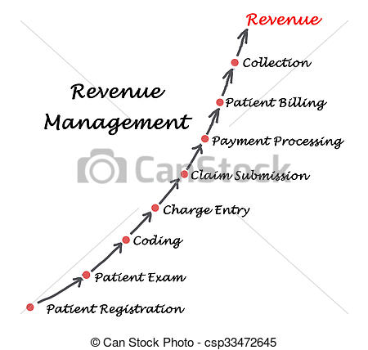

In the evolving healthcare landscape, hospitals and medical practices need new revenue cycle management (RCM) strategies. Choosing an experienced, technologically savvy medical billing service provider will ensure valuable support to optimize reimbursement. However, as the business of healthcare has become very complex, medical billing is no longer a simple administrative function. In a recent Beckers Hospital Review report, industry experts recommend specific new strategies to ensure that hospitals’ RCM efforts are focused and financially stable.

- Tracking claim denial rate: Following up on claims and denials is a critical aspect to enhance revenue generation. The claims tracking process involves reviewing accounts receivable (AR) and measuring the average number of days it takes to collect the payments due to the healthcare provider, and identifying patterns in payment by insurance companies. Automating key revenue cycle workflows, finding more efficient ways to submit clean claims, and improving collection efforts, and focusing on the appeals process can reduce days in AR and boost cash flow. In fact, AR management is an important element of the RCM solutions provided by medical billing companies.

- Review of chargemaster: Experts recommend that hospitals conduct a comprehensive review of their chargemaster and ensure price transparency for patients. This is an important requirement to prepare for the CMS' price transparency rule coming into force Jan. 1, 2019. Under CMS’ annual Inpatient Prospective Payment System rule, hospitals need to publish a list of their standard charges online in order to help patients understand the cost of care and prepare for any out-of-pocket costs. CMS also requires providers to update that information every year.
A recent report from the National Association of Healthcare Revenue Integrity, an expert recommends that hospitals take the following steps to prepare to post their chargesmaters online:

- Review existing state hospital pricing and price transparency requirements
- Review the chargemaster for consistent pricing
- Inform all stakeholders about the new requirements, including IT personnel responsible for the online posting of the chargemaster
- Fix a date for post the chargemaster
- Create customer service scripts to deal with patients’ questions about the chargemaster and pricing
Price transparency is critical to boost patient satisfaction and collection of patient financial responsibility.

- Reduce operating room delays and last-minute cancellations: Operating rooms are a very costly area of hospital operations. Depending upon the complexity of the procedure, last-minute cancellations or delays can prove very costly for hospitals. When planned surgical procedures are cancelled, it leads to considerable loss of revenue and waste of resources, and also results in significant psychological, social and financial consequences for patients and their families. Experts say that, to improve financial performance, hospitals should review their OR operations for avoidable costs and focus on minimizing cancellations and delays in procedures.
Strategies to improve OR operations include focusing on same-day cancellations, on-time procedure starts, equipment availability and parallel processing to increase efficiency.
- Blocking OR time by the day rather than stints of hourly blocks
- Adjusting block times based on the balance between under- and overutilization of the OR
- Avoiding potential delays and gaps for missing equipment by assessing the risk of potential problems in advance
- Avoiding tardiness in the OR by starting cases on time
- Turnover time reductions:
However, as ORs differ considerably based on patient population, type of hospital and type of surgery and anesthesia, it is difficult to set universal benchmarks for all Ors.

- Using online estimator tools to help patients understand their potential out-of-pocket costs: In an era of regulation, high-deductible plans and increased patient responsibility for bills, using a customer-friendly online estimator can ensure that patients get the information they want. Experian’s price-estimator tool, for instance, calculates patients' out-of-pocket cost based on the hospital's chargemaster price, its claims history for providing that service, its contract terms with the patient's insurer, and the patient's benefit structure and deductible status. It also estimates out-of-pocket costs for self-pay patient. Using a price estimator tool can boost patient satisfaction and attract more patients. Experts advise that when using the tool, hospitals should also post a disclaimer with standard charges, so patients know that the price list they are viewing may not indicate their actual out-of-pocket costs.

- Include both clinical interactions and nonclinical interactions when considering net promoter scores: Net promoter scores reflect how likely patients are likely to recommend the organization to another person. Patient care involves both clinical and nonclinical support services. Even the best clinical services cannot be truly optimal without dedicated nonclinical and clinical-support staff. Experts recommend that hospitals include both clinical interactions and nonclinical interactions when considering net promoter scores. Healthcare providers need to use the same approach as retail businesses and tap into what the patient not only wants but also expects by examining how every nonclinical touchpoint is interacting with the patient. Net promotion scores will provide hospitals with a more accurate picture of patient satisfaction.

Medical billing is the core of healthcare RCM. The medical billing process is complex and difficult to manage, but with the right processes, proactive strategies, and the support of an experienced medical billing and coding company, providers can optimize RCM and reduce days in accounts receivable.

